Give sufficient working out to obtain full marks in any questions involving calculations. Give ALL numerical answers correct to 3 significant figures unless otherwise stated or required by the given data.

Section A: Short answers

1. Identify the poles of the magnets whose 2-D field lines are shown. [4]
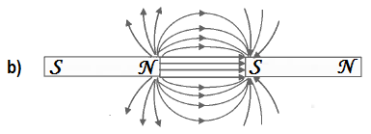
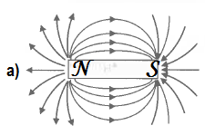

- 

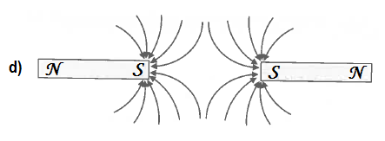
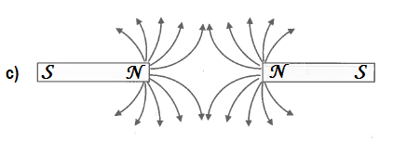
 
2. The horizontal magnetic field strength due to the Earth${ B}_{HE}$, at a certain location, has the same magnitude as the magnetic field strength due to any pole of the two magnets shown of equal strength at the locations marked $A, B, C and D.$ Sketch the resultant magnetic field at each of those locations due to a combination of the magnets and the Earth’s horizontal magnetic field. Consider only the effect of the pole(s) closest to the points and the Earth’s field. [4]
R_{A}
B_{HEA}
B_{N}
B_{S}
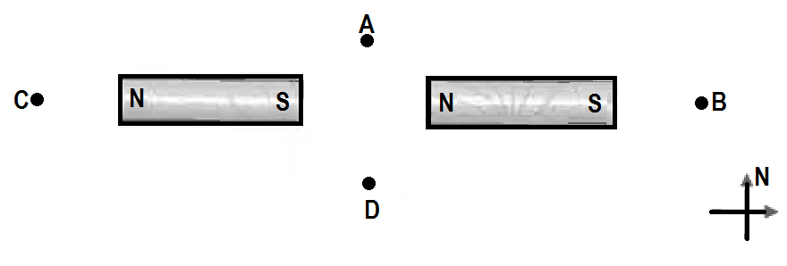

R_{D}
B_{HED}
B_{N}
B_{S}



B_{HEB}
B_{S}
R_{B}
R_{C}
B_{HEC}
B_{N}

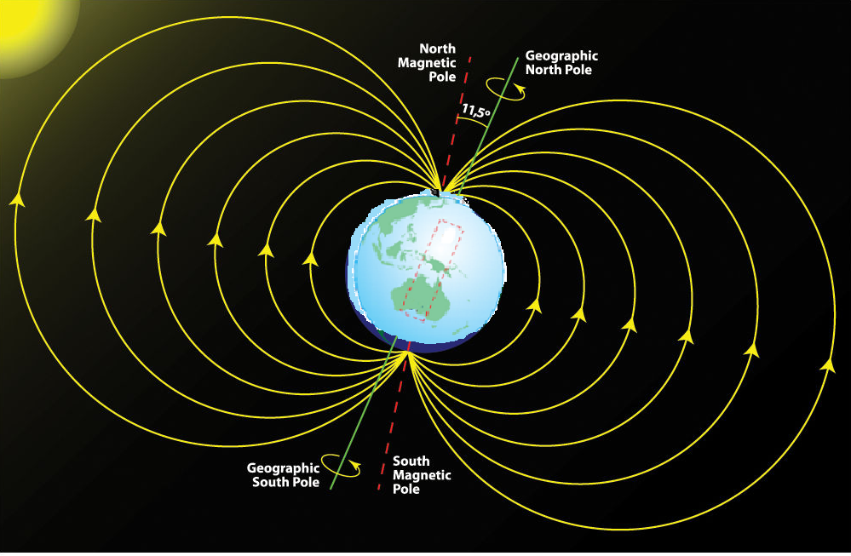
3. On the map of the world provided, mark the following:




(i) The Magnetic North Pole [1]
(ii) The Magnetic South Pole [1]
(iii) 8 magnetic field lines symmetrical about the magnetic axis. [4]

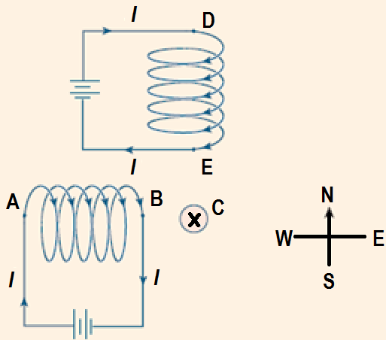
4. The diagram shows two current-carrying solenoids located equidistant from and at right angles to a long, straight, current-carrying conductor$C$ (perpendicular to page) that carries a current into the page.
The magnitude of the magnetic force due to the solenoids on C is 5.00 µN.
(a) In what direction is the magnetic force on$C$? [1]
South West 
(b) The direction of the current in the solenoid$DE$ is reversed and its magnitude halved. The current in conductor $C$ is also reversed and its magnitude doubled. Calculate the force on conductor$C$now? [3]
B
B
B$\sqrt{2}$
F = IB$\sqrt{2}$L
= 5 µN

F = 2×I ×B$\frac{\sqrt{5}}{2}$L= IB$\sqrt{5}$L= $\frac{\sqrt{5}}{\sqrt{2}}$×IB$\sqrt{2}$L
=$\frac{\sqrt{5}}{\sqrt{2}}$×5 µN =7.91 µN at N tan⁻¹(1/2) W
= 7.91 µN at N 26.6º W

B
$$\frac{B}{2}$$
B$\frac{\sqrt{5}}{2}$

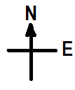
5. Each diagram below shows 50.0 cm of current-carrying conductor within a magnetic field. Calculate the force acting on each conductor due to the magnetic field.
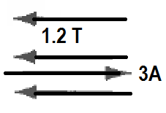
a) [2]
F = 0 ( I and B are parallel) 

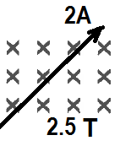

b) F = 2 × .5 × 2.5 = 2.50 N North West  [2]

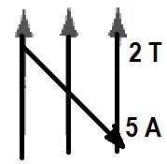
c) F = 5 × .5 × 2 sin45 =3.53 N out of the page  [2]

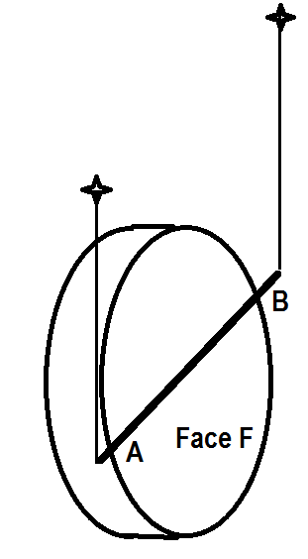
6. In an experiment students suspended a copper wire $AB$beside a face $F$ of a disc magnet as shown. They noticed that when the wire was connected to a $DC$ supply, it moved up (was levitated).
a) Which choice correctly shows the direction of the current in the wire and the polarity of the face$F$? Circle the correct one. [1]
(A) Current from $A to B$ and face $F$ polarity is north.
(B) Current from B to A and face $F$ polarity is south.
(C) Current from B to A and face $F$ polarity is north. 
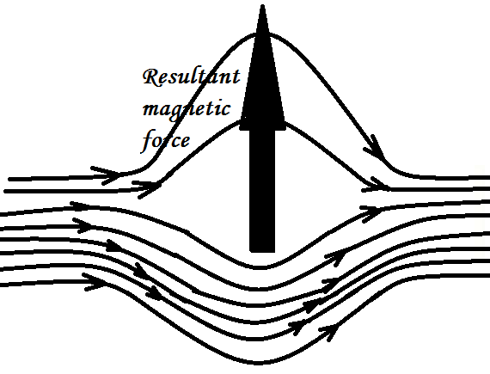
b) Explain in detail your choice. You must draw appropriate magnet field interaction diagrams and a simple mention of the right hand slap rule is not sufficient. [3]
As current flows from B to A, (Out of the page), concentric anticlockwise magnetic field lines are formed. If Face F is a North pole the magnetic fields go from it to the right as shown on the left diagram above.
The result is that the magnetic field lines strengthen to form a stronger field below the conductor and a weaker field above the conductor. The resultant is an upward pushing magnetic force that levitates the conductor as shown in the diagram above right. 

7. Transformers are devices that step up and step down voltages for many applications.
a) Why are transformers laminated? [2]
Most transformers are made of bulk conducting soft iron to intensify the magnetic field through it as the magnetic field through it changes. This generates a lot of eddy currents within the core of the transformer. These eddy currents lead to heating up the transformer and are an energy loss source for transformers.
To minimise the formation and flow of huge eddy currents, transformers cores are laminated so that the pathways of these currents consist of thin laminated strips so large eddy currents are unable to flow, thereby reducing heat generation and energy loss. 

A 75% efficient transformer is needed to supply two 12−Ω globes an RMS output voltage of 60.0 V. The input voltage is 3.0 V RMS.
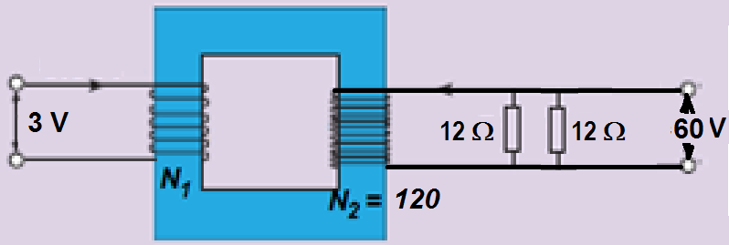

There are 120 turns in the secondary winding.
a) What is the RMS output current? [1]
Resultant output resistance = 6 Ω
V = IR ∴ I = V ÷ R = 60 ÷ 6 = 10.0 A RMS 
b) How many turns are there in the primary winding? [1]
$\frac{N_{1}}{N_{2}}=\frac{V_{input}}{V_{output}} \frac{N_{1}}{120}=\frac{3}{60} N_{1}=6 turns$ 

c) How much power is generated by the input source? [1]

$Input power= \frac{Output power}{efficiency}= \frac{60 10}{0.75 }=800 W$ 

d) What is the peak input current? [1]
Peak input current = $\sqrt{2} Input current= \sqrt{2} \frac{P}{V}= \sqrt{2} \frac{800}{3}=377 A peak$ 

Section B. Calculations

8. The following is a simplified diagram of a DC motor
(a) Briefly write down the functions of the following parts.
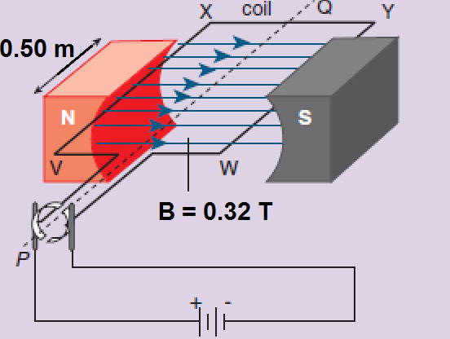
(i) Battery [1]
Supplies the potential difference and current required in the coils that produces a magnetic field to interact with that of the field magnets, resulting in magnetic forces that spin the coils. 

(ii) Soft iron core or armature (not shown) [1]
These intensify the magnetic field linking the coil so the force produced is the highest possible. It also helps the commutator to not stall when the brushes momentarily lose contact with the commutators. This is because the inertia of the armature makes that extra turn that engages the other half of the split ring commutator. 

(iii) Split ring commutator [1]
These enable the current in each half of coil to reverse once every ½ rotation, so that the force, torque and motion of the motor will continue in one direction. 

(iv) Carbon brushes [1]
These enable current to be transferred from fixed cables from a cell, into rotating coils via commutators without getting the wires twisted up and tangled. 

(b) The coil shown has 100 turns. The side XY is 1.00 m. and caries a current of 0.50 A. Calculate the magnetic force on the following sides at the instant shown:
(i) VX [1]
Effective L = 0.5 m, I = 0.5 A, B = 0.32 T, N = 100
∴ F = NIBL = 100 × 0.5 × 0.32 × 0.5 = 8.00 N downward
(ii) XY [1]
Side XY has current flowing at the instant parallel to B ∴ F = 0.00 N 
(iii) YW [1]
Side YW is parallel to side VX ∴ the force magnitude on side YW is same as that on side VX but direction is opposite, ∴ Force on VX = 8.00 N upward 
(c) Calculate for the instant shown, the torque on the coil and state which direction the coil will rotate (clockwise or anticlockwise) as viewed from the split ring side. [2]
Torque on coil, τ = 2 × 8 × ½ = 8.00 N.m anticlockwise 
(d) Sketch a torque versus time graph for one complete rotation, using the shown position as zero time. [2]
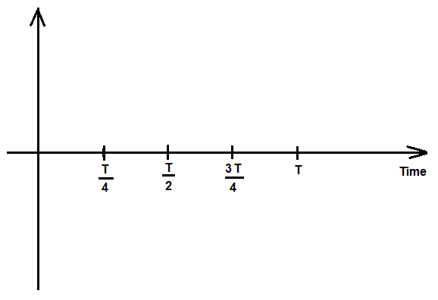

  

(e) List four ways in which the DC motor could be modified so the maximum torque could increase. [2]
Since τ = NAIB, increasing (N the number of turns); Increasing, A (The area of the coil), Increasing I (the current through the conductors) and Increasing B(the magnetic field ) would increase the maximum torque. 
(g) Motors can be used as generators if they are modified in a certain way. How could this motor be converted into a generator? [2]
Attach a turbine to the axle and spin the axle via the turbine or some other arrangement to spin the acle, this spins the coil in the magnetic field and as the flux linking the coil changes, emf is induced in the coil.
The induced emf can be output through the carbon brushes and used to provide power as required. The cell is replaced by the load that requires the induced emf. 
(h) If the motor was modified and converted into a generator, would the generator produce AC or DC current? Explain briefly. [1]
If the commutators remain as split ring, then the output will be ½ wave rectified AC. The commutators will ensure the output is in one direction only even though it varies between 0 and maximum values. If the commutators is slip ring, then the output would be AC. 

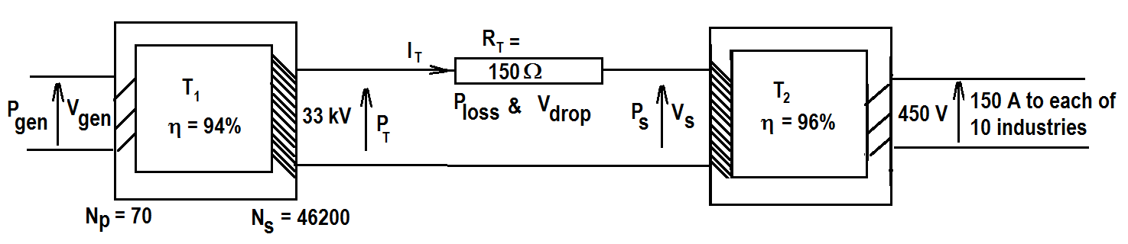
9. An industrial estate with 10 industries each needing $150 A$ at $450 V$ is supplied by a generating station. The generated voltage, $V_{gen}$ is stepped up to $33 kV$ across a $94\%$ efficient transformer$T_{1}$. The input coils to $T_{1 }$have $70$ turns and the output coils have $46200$ turns. The transmission line total resistance${ R}_{T}$ is$150$. At the substation to the industrial estate, the input voltage $V_{s}$to a second $96\%$ efficient transformer$T_{2}$ is stepped down to the required$450 V$.

a) What is the total current drawn by the ten industries? [1]

I_{Total} = 150 × 10 = 1500 A 

b) What is the power output to the industrial estate? [2]

P_{Output} = 450 × I_{Total} = 450 × 1500 = 675000 W = 675 kW 

c) What is the power input $P_{s}$ to the substation transformer$T_{2}$? [2]

$P_{s}=\frac{P_{Output}}{0.96}=\frac{675000}{0.96}=703125 W 703 kW$ 

d) What is the generated voltage,$V_{gen}$? [1]

$\frac{V_{gen}}{33000}=\frac{N_{p}}{N_{s}}=\frac{70}{46200} V_{gen}=\frac{70}{46200} 33000=50.0 V$ 

e) Write an expression for the transmission line current $I_{T}$ in terms of$P_{s} and V_{s}$.
[1]

$I_{T}=\frac{P_{s}}{V_{s}}= \frac{703125}{V_{s}}$ 

f) Calculate the power output of the generator$P_{gen }$. [2]
$P_{T}=P_{s}+ P_{loss}=703125+ {\left(I_{T}\right)}^{2}R_{T}=703125+{\left(\frac{703125}{V_{s}}\right)}^{2} 150$ …i
$33000= V_{s}+ V_{drop}= V_{s}+ \frac{703125}{V_{s}}150=V_{s}+\frac{105468750}{V_{s}}$ …ii
Equation ii can be solved to give
$${V_{s}}^{2}-33000V_{s}+105468750=0 \\ V_{s}=\frac{-b±\sqrt{b^{2}-4ac}}{2a}=\frac{33000±\sqrt{{\left(-33000\right)}^{2}-41105468750}}{21}$$$= \frac{33000±\sqrt{667125000}}{2}=\frac{33000±25828.76304}{2}=29414.4 V or 3585.6 V$ 
The correct V_{s} = 29414.4 V and 3585.6 is the voltage drop V_{drop}
∴ from equation …i, $P_{T}=703125+{\left(\frac{703125}{29414.4}\right)}^{2} 150=788835.958 W$
∴ $P_{gen}=\frac{P_{T}}{0.94}=\frac{788835.958}{0.94}=839187.1896 W 839 kW$ 

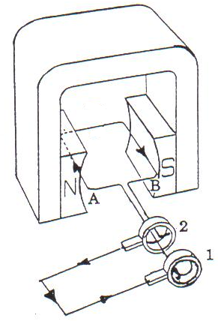
10. The diagram below is that of a simple AC generator. At the instant shown the emf generated produces current as indicated.
a) Which direction is the coil spinning? (Clockwise or anticlockwise? As viewed from the commutator’s end.) [1]
Clockwise 
b) The magnetic field in the coil area is of intensity 0.45 T. The 20 cm × 20 cm coil has 150 turns and is spinning at 3000 rpm. Calculate:
(i) The frequency of rotation of the coil in Hz. [1]
$f= \frac{speed in rpm}{60 }= \frac{3000}{60}=50.0 Hz$ 
(ii) The flux linking the coil at this position. [1]
At this position no flux links the coil ∴ φ = 0.00 Wb 
(iii) The flux linking the coil after ¼ turn from the horizontal position shown. [1]
After ¼ turn flux in maximum $=BA=0.45 0.2 0.2=0.0180 Wb$ 

(b) Sketch the following graphs for one full cycle.
(i) Flux Φ versus time graph [2]
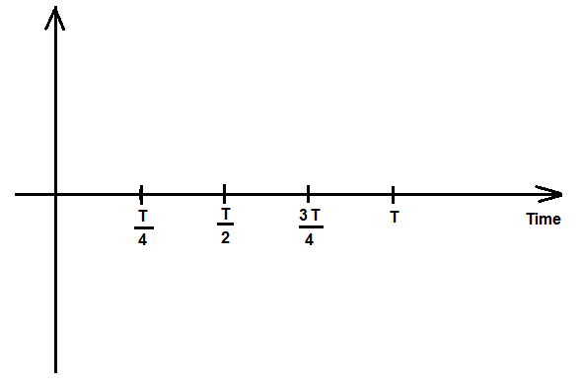
Flux (Wb)
0.018
−0.018

(ii) The induced EMF versus time graph. [2]

Maximum induced emf $=\sqrt{2} \frac{N}{ t}= \sqrt{2} \frac{150 0.018}{0.005}=763.7 764 V$


Induced emf (V)
764
−764

c) What changes would be observed in the induced emf if the coil was spun at 9000 rpm? [2]
i) The period, T will be reduced from 0.02 s to 0.00667 s 
ii) The emf induced will triple (the maximum will be 3 × 763.7 = 2291 V ≈ 2290 V 
iv) What changes would be observed in the induced emf if the coil was spun at 1500 rpm? [2]
i) The period, T will be increased from 0.02 s to 0.04 s 
ii) The emf induced will half (the maximum will be ½ × 763.7 = 381.85 V ≈ 382 V 

Section C: Experimental interpretation:
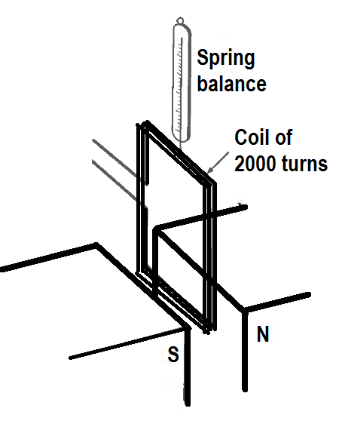
11. A group of students set up a 2000 turn rectangular coil of wire suspended from a spring balance so that its lower side (5 cm in length) was between the poles of a magnet as shown in the diagram.
They passed various currents through the coil and recorded the reading on the spring balance. Their results are shown.

Current in coil (A) | Reading on balance (N)
0 | 3.7
1 | 3.8
2 | 3.9
3 | 4.0
4 | 4.1
5 | 4.2

a) Identify three factors that have been controlled. [3]
The coil material, shape and the number of turns in the coil
The magnet, material and field
The positioning of the coil in the magnetic field
The spring balance
The room conditions (temperature, pressure, humidity etc.) 

b) Identify the dependent variable. [1]
The spring balance reading 
c) Identify the independent variable. [1]
The current in the coil. 
d) Determine which direction the current must flow in the coil as viewed from the left to produce the experimental results. (Clockwise or anticlockwise?) [1]
Anticlockwise 
e) Graph the results of the experiment. [4]
1000 turns magnet 
Double strength magnet 
Title + Axes labels + good scales  Points correctly plotted 
Straight line well drawn with sharp pencil  Line occupies more than ¾ of graph 

f) Analyse the graph and the related equations from your formula sheets to calculate the following:
i) Mass of the coil. [1]
Weight of coil = Balance reading when I = 0 = 3.7 N
∴ mass of coil = W ÷ 9.8 = 3.7 ÷ 9.8 =0.37755 kg ≈ 378 g 

ii) Strength of the magnetic field. [2]
$F=NBLI+W_{coil}$ The slope of the F versus I graph is NBL
$$NBL=2000 B \frac{5}{100}=0.1$$$B=\frac{0.1}{2000} \frac{100}{5}=0.001 T$ 
iii) Reading of the spring balance if a current of 12.0 A was flowing in the coil. [2]
Substitute in the equation:
F = 0.1 × 12 + 3.7 = 4.90 N 

iv) Reading of the spring balance if a current of 5.0 A was flowing in the opposite direction through the coil. [2]
F = 0.1 × −5 + 3.7 = 3.20 N 

v) The students repeated the experiment with the same coil but with a magnet twice as strong. On your axes above, draw and label a second graph to predict what their results would be. [1]

vi) The students then repeated the original experiment again, this time using a coil with 1000 turns. Graph and label the results you would expect on the same axes above. [1]

END OF TOPIC TEST

